FINAL PROJECT AND CERTIFICATION OF GROWIA

Halo Students, welcome to Growia's SQL final project, It will be fun and make you more confident in the Software Testing field. Please follow the instructions below.

Instructions

**STEP 1:** Open the following URL <https://www.programiz.com/sql/online-compiler/>

**STEP 2:** Solve the problems given under the Task sections

**STEP 3:** Take a screenshot and query you used and put them together in a doc/slides file to be presented.

Problems

Create a query resulting in the following data:

1. Shows all Customers who are older than 25 years old. Output should be as follows:  
   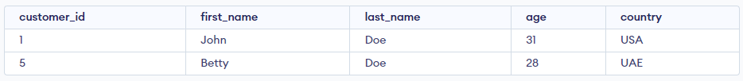
2. Shows the data for all Delivered shipments. Output should be as follows:  
   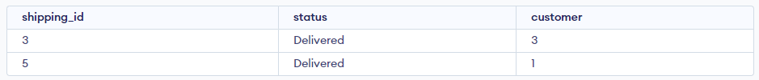
3. Shows the records from the Orders table that were made by John Doe. Output should be as follows:  
   
4. Shows the Customers first name and last name who made an order more than or equal to 400. Output should be as follows:  
   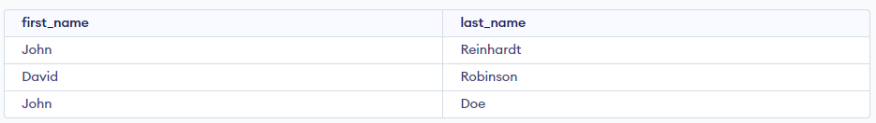

Deliverables

1. Doc/Presentation slides

Good Luck!